**International - National Security and Sovereignty**

1. **Conceptual Framework of International Security, National Security and State Sovereignty**

A.1. **Importance of Security:**

The study of security was initiated as a way to overcome the consequences of armed conflicts. Therefore, the concept of security cannot be underestimated.

A.2. **Defining International, National Security and Sovereignty of a State:**

**A.2.1. International Security & its Concept:**

The concept of **international security** as security among states belongs to the twentieth century. Threats are no longer primarily coming from states. Threats are coming from ethnic groups obsessed by hyper nationalism, from criminal gangs, Mafiosi governance, from epidemics, AIDS, terrorism, dangerous food, from poverty, from economic mismanagement, from over-population, from failed states, from flows of refugees, and, most importantly, from pollution and the effects of pollution, the irrigation and destruction of nature, and the diversification of nature. **(INTERNATIONAL RELATIONS – Vol.II – International Security - Bertel Heurlin – A Danish Political Scientist)**

**OR**

**International security**, also called global security, is a term, which refers to the measures taken by states and international organizations, such as the United Nations, European Union, and others, to ensure mutual survival and safety. **(Encyclopedia Britannica)**

**A.2.2. National Security & its Concept:**

**National security** can be described as the ability of a state to cater for the protection and defense of its citizenry **(UN).**

* The nation state defines the standard of acceptable conduct
* Within that conduct, citizens can pursue their own ends free from outside interference.
* Hence, national security is often presented as a reciprocal arrangement.
* Use of force by nation state or state agents is only for the public good and not for personal power or aggrandizement.
* Public officials are therefore responsible for providing both national security and personal security and they can be held to account for neglecting or failing to fulfil their security mandate
* At the same time, citizens can be condemned for ignoring or violating any reasonable security demands placed upon them
* **From above-mentioned aspects, the term ‘national security’ refers to all those public policies through which the nation state ensures its survival as a separate and sovereign community and the safety and prosperity of its citizens.**

**A.2.3. State Sovereignty and its Concept:**

*The supreme, absolute, and uncontrollable power by which an independent state is governed and from which all specific political powers are* *derived; the intentional independence of a state, combined with the right and power of regulating its internal affairs without foreign interference.* ***(Legal Dictionary)***

***OR***

**State sovereignty**, in political theory, the ultimate overseer, or authority, in the decision-making process of the state and in the maintenance of order. It is derived from the Latin **superanus** through the French **souveraineté**. **(Encyclopedia Britannica)**

1. **International Framework of International Security, National Security and State Sovereignty**

**Expected Essay Topics**:

[**Will do later**] Is Future of State Sovereignty looking bleak?

Modern Wars are Cyberwars **OR** Modern Wars will be fought in Cyberspace **OR** Modern Wars are Hybrid Wars

**Human Security and National Security are Mutually Inclusive**

**Body Arguments:**

1. **Evolution and Understanding of the Concept (1st Para)**
   1. The concept of ‘human security’ was developed in the UNDP’s 1994 *Human Development Report.* Defining human security as “safety from such chronic threats as hunger, disease and repression” and “protection from sudden and hurtful disruptions in the patterns of daily life,” the UNDP broadened the concept of security.
   2. This concept of human security was based on the recognition that all persons are subjects of dignity and rights.
   3. The idea of ‘state’ or ‘national’ security is too often misinterpreted as solely the defense of states’ borders from external threats. On the contrary, given the changing nature of today’s dangers, it has to do primarily with the protection of its citizens and the rule of law and, therefore, it is about human security.
   4. The state is often regarded in the human security perspective as just one of the actors, or even part of the problem itself.
   5. On the contrary, it should be considered the central security provider: its stability and legitimacy are the main sources of protection for its citizens, from any kind of threats.
   6. The strengthening of national authorities should be a central strategy to ensure the protection of the people.
2. **How are Human Security and National Security Mutually Inclusive (2nd -7th Para)**
3. **Post-Cold War world poses a plethora of different security problems** (Sir Richard Jolly who is a Honorary Professor and Research Associate of the Institute of Development Studies at the University of Sussex)**.**

Thus, the world needs a holistic approach to maintain nation security in the form of human security. Similarly, this concept may also bolster co-operation between international agencies in the fields of security, development and human rights. Broadness facilitates coalitions, which, in turn, allow previously neglected issues to gain greater attention on international agenda. For example, this adoption of a human security narrative is often considered as a key driver behind the campaign to ban landmines in the 1990s. Moreover, the ban is usually referred to as the **Ottawa Convention** or the **Anti-Personnel Mine Ban Treaty**.

1. **Human security approach enables state to reduce class conflict; thereby, ensuring national security. (Case Study)** For a long time now, Pakistan had an extremely poor health system for its populace, however with the introduction of ‘Insaf Sehat Card’ or the health insurance, people may be able to get some quality treatment.The incumbent government introduced this programme to provide essential medical facilities to all citizens starting from the poorest segment of the society.
2. **Human security policy emphasizes on strengthening state institutions to cater for traditional security threats for national security**
3. **Human security addresses the issue of environmental security to tackle non-traditional threat for ensuring national security.** The launching of ‘Ten Billion Trees Tsunami Programme’ is expected to be a game changer. The programme aims at restoring the ecosystem which has been largely recognized by the global leaders and institutions, aims to fight the effects of climate change.
4. **Counter Perspective: However, some people partially believe that Human Security Is normatively attractive or analytically weak concept in maintaining national security (8th Para)**
   1. **Even Lakhdar Brahimi**, former special representative to Afghanistan, Iraq, and Haiti, and chair of the UN Panel on Peacekeeping, once said, “I don’t use the term human security because I don’t know exactly what I mean, and I worry that someone will come up and contradict me.”
   2. **Buzan** (Barry Gordon Buzan is Emeritus Professor of International Relations at the London School of Economics and honorary professor at the University of Copenhagen and Jilin University.) and **Taylor Owen** (an expert at Centre for International Governance Innovation) make the important point that defining human security broadly under its seven components means little. This, in turn, poses a practical dilemma for policy-makers charged with the allocation of already scarce resources.
   3. Finally, certain critics of human security have argued that the human security concept disempowers weak and underdeveloped states, opposing the counter-narrative of the advocates who depict human security as emancipatory.
5. **Suggestions for Integrating Human Security based Approach in National Security Strategy**

**B.1. Dimensions of National Security and Sovereignty**

**B.1.1 National Security and Sovereignty in wake of Computer and Cyber Security**

Cyber warfare is usually defined as a cyber-attack or series of attacks that target a country. It has the potential to wreak havoc on government and civilian infrastructure and disrupt critical systems, resulting in damage to the state and even loss of life.

**Types of Cyber Attacks:**

### Espionage

### Refers to monitoring other countries to steal secrets. In cyber warfare, this can involve using botnets or spear phishing attacks to compromise sensitive computer systems before ex-filtrating sensitive information.

### Sabotage

Government organizations must determine sensitive information and the risks if it is compromised. Hostile governments or terrorists may steal information, destroy it, or leverage insider threats such as dissatisfied or careless employees, or government employees with affiliation to the attacking country.

### Denial-of-service (DoS) Attacks

DoS attacks prevent legitimate users from accessing a website by flooding it with fake requests and forcing the website to handle these requests. This type of attack can be used to disrupt critical operations and systems, and block access to sensitive websites by civilians, military and security personnel, or research bodies.

### Electrical Power Grid

Attacking the power grid allows attackers to disable critical systems, disrupt infrastructure, and potentially result in bodily harm. Attacks on the power grid can also disrupt communications and render services such as text messages and communications unusable.

### Propaganda Attacks

Attempts to control the minds and thoughts of people living in or fighting for a target country. Propaganda can be used to expose embarrassing truths, spread lies to make people lose trust in their country, or side with their enemies.

### Economic Disruption

Most modern economic systems operate using computers. Attackers can target computer networks of economic establishments such as stock markets, payment systems, and banks to steal money or block people from accessing the funds they need.

### Surprise Attacks

These are the cyber equivalent of attacks like Pearl Harbor and 9/11. The point is to carry out a massive attack that the enemy isn’t expecting, enabling the attacker to weaken their defenses. This can be done to prepare the ground for a physical attack in the context of hybrid warfare.

**Examining Cybersecurity as a Threat to National Security:**

1. According to **John Arquilla**, who is an American analyst and academic professional of International Relations, stated in his book ‘**The Advent of Netwar**’ that cyberwar is inevitable and will sooner or later lead to a catastrophe in which an entire nation is brought down to its knees while a great many of its people are killed in the process. What makes the matter worse is the difficulty of tracing an attack to its origin or identifying the intentions of a perpetrator behind a computer.
2. A few notable examples of cyberattacks in history would be fitting to recall here: **Stuxnet Attack** - on a major nuclear facility in Iran, the **2007 attack on Estonia** - affecting the government, financial system and communication networks amongst others, the **2008 attack on Georgia** - affecting command and control and making vulnerable the military against a conventional attack, and the attack on the Japanese multinational conglomerate corporation, **Sony** - which led to its loss of a significant amount of data and financial resources.
3. Indeed, it is worth mentioning here that even cybercrime which is usually seen as a matter concerning individual civilians, can equally target national infrastructures. One is particularly reminded of transnational criminals sponsored by foreign governments to undertake ‘plausibly deniable’ cyber operations: an illustrative example being the 2007 cyberattack on Estonia, allegedly undertaken by a group of Russian hackers on behalf of the Russian government.
4. In October 2020, Hackney Council in the UK suffered a ransomware cyber-attack, which caused many months of disruption and cost millions of pounds to rectify. At a critical time when it was dealing with the impact of the COVID-19 pandemic, the council was locked out of important data and many services were disrupted**.**
5. Opposite to **JOHN Aquilla’s view of Cyberwar**, according to Thomas Rid in his book ‘**Cyber War Will Not Take Place**’, cyberwar will never take place in the future. This is because war in cyberspace (cyberwar) does not meet the three criteria essential for defining war in its traditional, Clausewitzian sense: war as potentially violent, instrumental (that is, as a means to an end), and political in nature. In this respect, he adds that no single cyber ‘incident’ of any kind in history has ever met all three altogether. He additionally states that fear of self-inflicting collateral damage further discourages states from engaging in offensive attacks.
6. **National Security & Pakistan**

**C.1. New National Security Policy of Pakistan (NSP) 2022-2026**

**C.1.1 Salient Features of NSP**

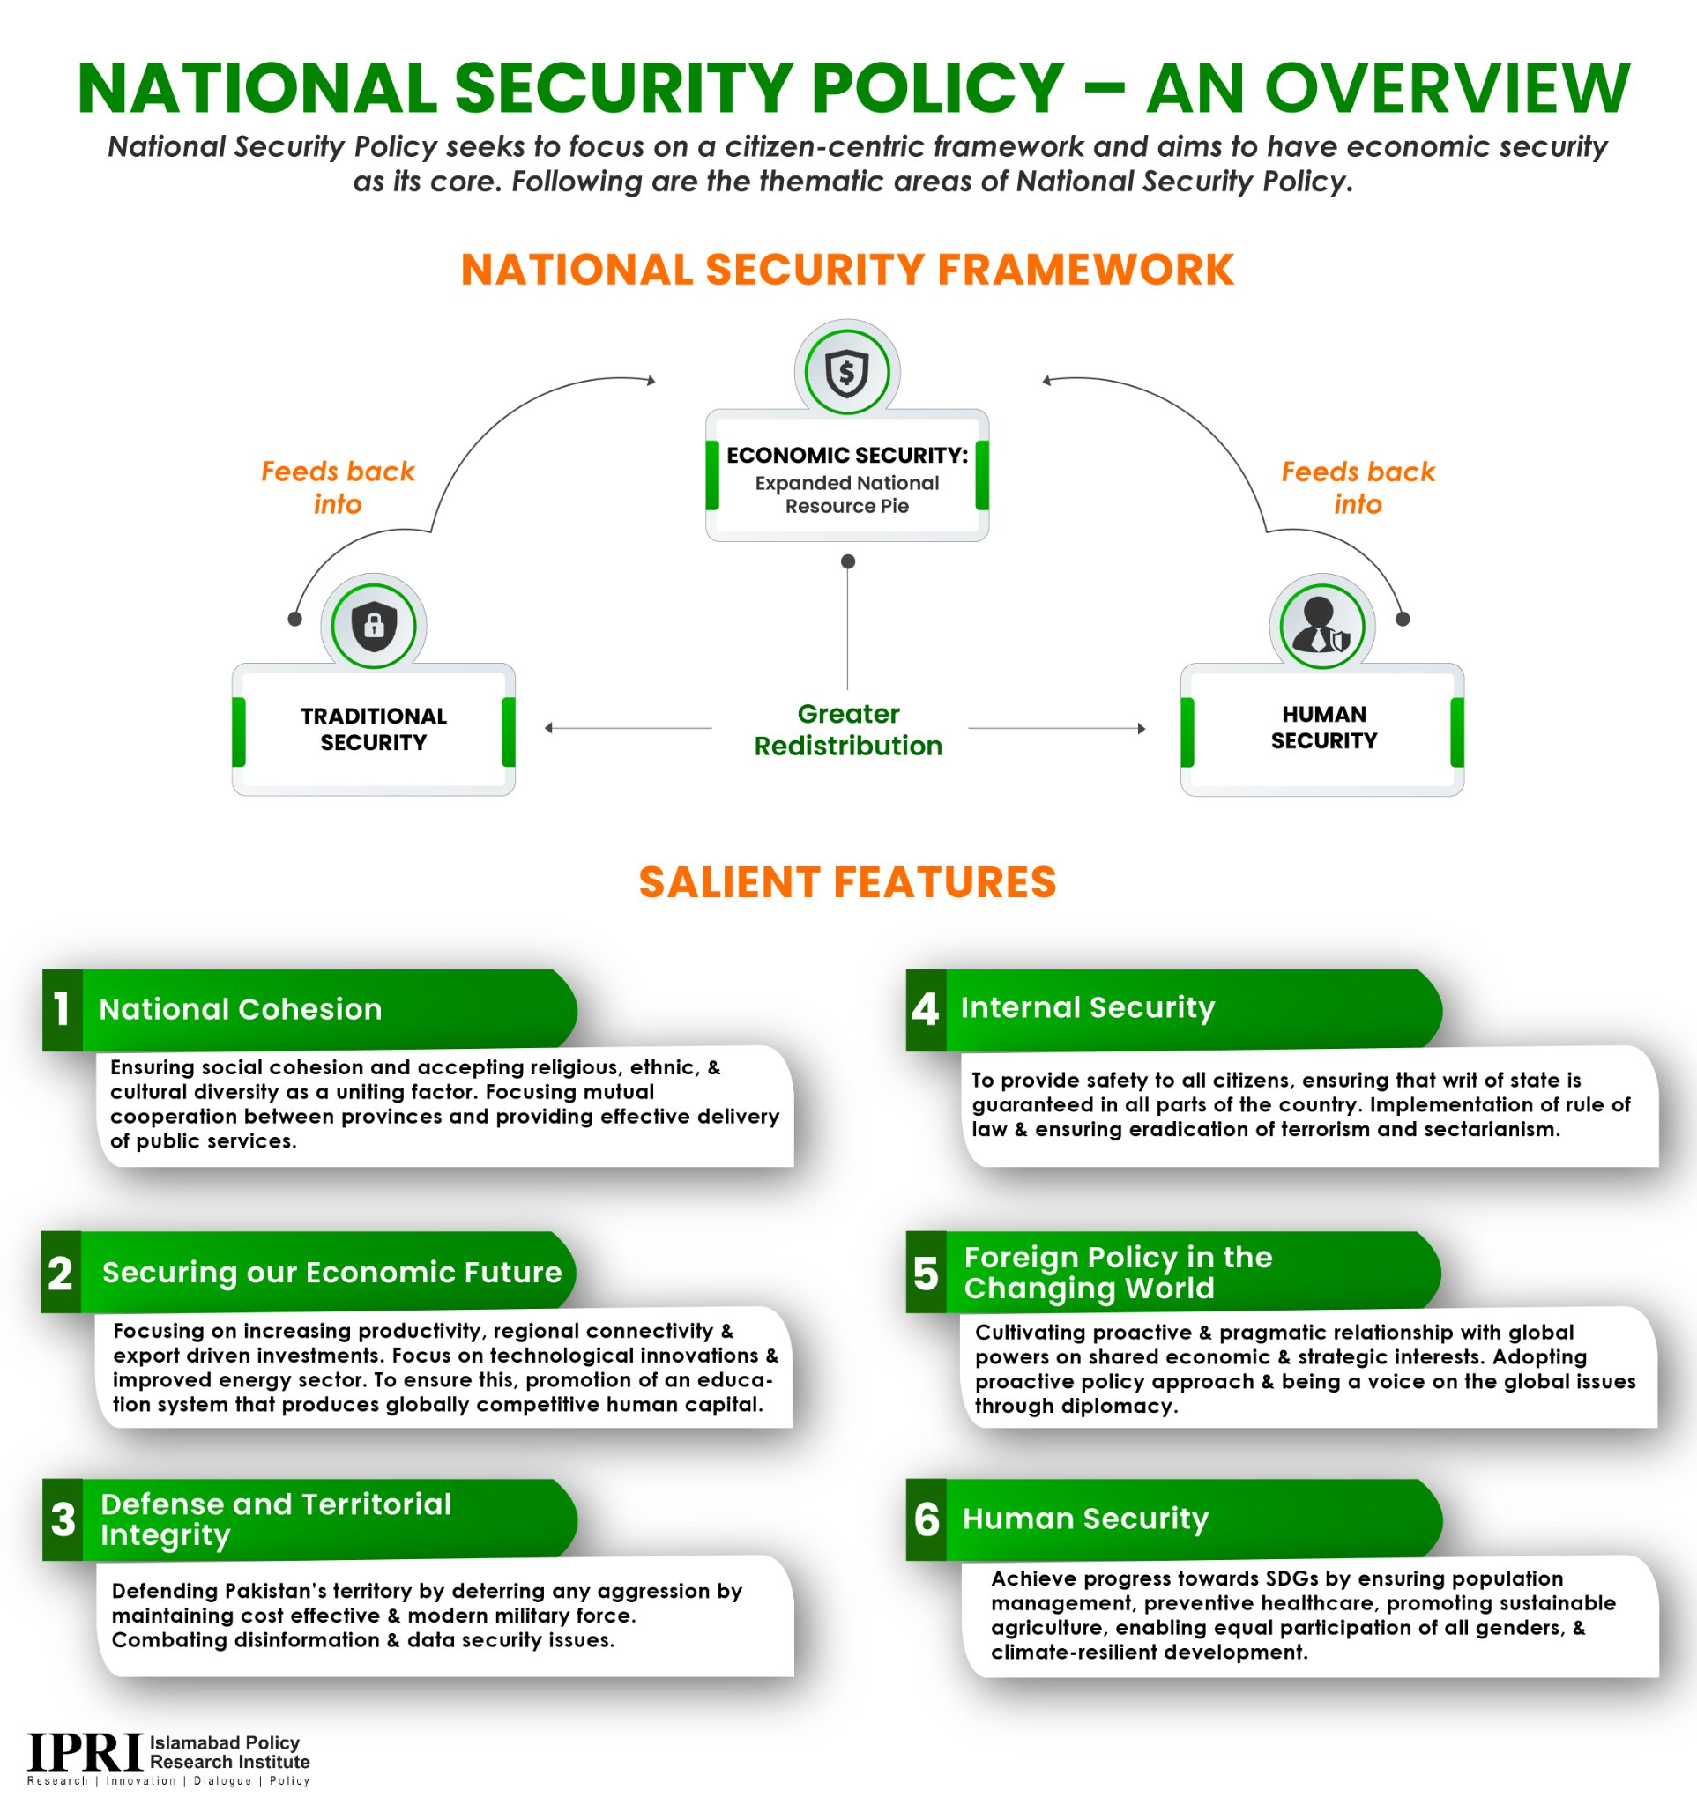

**C.1.2. Critical Analysis of NSP**

**Below videos are highly recommended:**

**(TCM Original about NSP)**

[**https://www.youtube.com/watch?v=mvFGUg74p9k**](https://www.youtube.com/watch?v=mvFGUg74p9k)

**(World Times on NSP)**

**https://www.youtube.com/watch?v=dK8mfzYpONI**

**(Al-Jazeera)**

[**https://www.youtube.com/watch?v=f9IwgbKCGsc**](https://www.youtube.com/watch?v=f9IwgbKCGsc)

1. It states about the main intent of the country was that the country has moved on towards peace, economic security in tandem with geo-strategy, and human security.
2. NSP (2022-26) was drafted after negotiations in the National Security Committee of the Parliament, denying the notion that it is drafted without the consensus of the opposition parties.
3. NSP needs funding for its successful implementation. Whilst taking into account for Pakistan’s record high external and internal debt, heightened inflation, and a low Tax-to-GDP ratio of 8.6 percent, it is onerous to implement.
4. Maintaining peace is also crucial for execution of NSP. The peace, at both the borders, with India and Afghanistan will help the government and administration to implement it with focus.
5. NSP has recently added 5-domain security paradigm varying from, air, sea, cyber, and space.
6. With an eye on India’s investment in a variety of disruptive technologies, the NSP highlights Pakistan’s need to invest in upgrading cyber security for its critical infrastructure, securing its networks to minimize cyber intrusion and surveillance
7. By bringing geo-economics into the center of the concept, the NSP draws a clear vision for policymaking at the national level.
8. The issue of trade with India may provide a test case. Geo-economics may require Pakistan to relook at the decision of not trading with India.
9. A document filled with worthy objectives and not a single concrete step on how to attain any of them is surprising - need to promote delivery-based good governance.
10. Bizarrely, this ‘citizen-centric’ document was not presented in parliament, a forum representing the people’s collective will.
11. This is the first time any NSP in Pakistan has taken a comprehensive approach to **security**, anchoring its drift in human security to achieve economic security. Whether it is about securing a citizen’s constitutional privileges, or about protecting a regular Pakistani from all forms of extremism, crime, terrorism, and violence–including war–the new NSP has it covered. This is also the first time in the history of Pakistan that gender security has found its place in the NSP document aiming to protect the citizens of Pakistan from structural violence, including inequality in workplaces and gender-based violence.
12. In order to prioritize **human security**, the NSP makes specific references to the rule of law to be upheld for all citizens, ensuring a responsive justice system that is impartial and holds all citizens accountable equally
13. What the NSP does not lay out is how Pakistan will enhance productivity, generate savings, promote investment, practice fiscal prudence and address the external imbalance. The section on economics lists external imbalance, horizontal inequalities (between regions) and vertical inequalities (between different classes).
14. **The mismanagement of the economy—high inflation, low growth, shortages of energy and other essentials, joblessness, and skyrocketing tariffs on fuel and energy—have actually raised economic distress levels to unbearable levels.**
15. There appears to be more focus on regional economics than the domestic economy. For instance, the policy mentions CPEC as an epitome of the regional connectivity paradigm, **describing** the project as “providing impetus to Pakistan’s economy with the potential to jump-start domestic growth.” However, it is unclear if CPEC has translated into prosperity and development at home
16. Secondly, there is no mention of the sectors or products that Pakistan can capitalize on and exercise its competitive advantage. While there is a mention of increasing productivity of agricultural sectors in the document, it is worth noting that trade driven by the agricultural sector may not be sustainable for Pakistan given that climate-change-induced impacts are likely to reduce agricultural productivity. In the human security section, the NSP itself **articulates** the impact of decreasing availability of farmland and per capita availability of water on the agriculture-based economy.
17. On one hand, the policy **states**, “Pakistan’s share of clean energy should reach sixty percent by 2030.” On the other hand, Pakistan is keen to connect Central Asian states with the South Asian ones, given the energy abundance in Central Asia and the increasing demand in South Asia. Thus, integration projects dependent on non-renewable energy sources, such as the TAPI gas pipeline, come up against the policy